LA SPRING 2026
MID A
GRADING DECISIONS
Q 1. (a) The given equation is NOT true. This can be shown with any correct counterexample. The simplest one would be to use two 2 x 2 matrices, such as the case below to disprove the result:

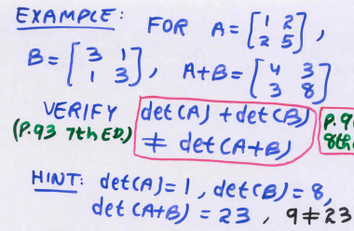

(b) 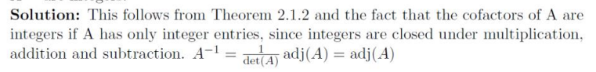

MARKING SCHEME
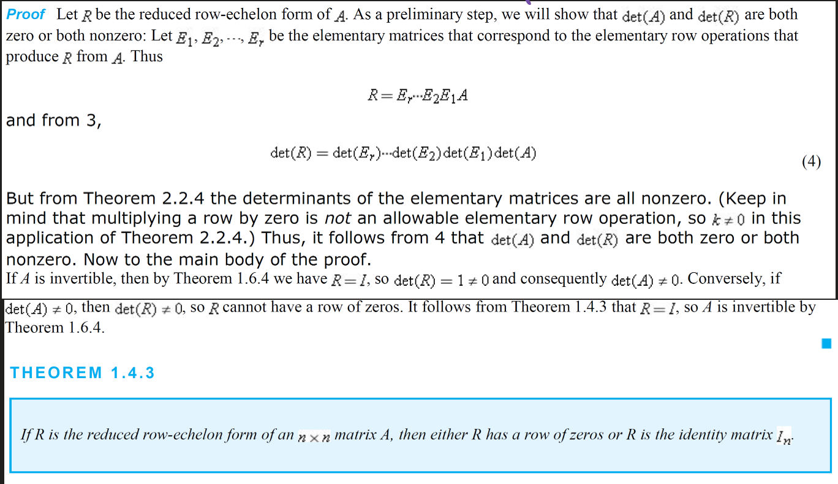
Q. 2
MARKING SCHEME

Q. 3
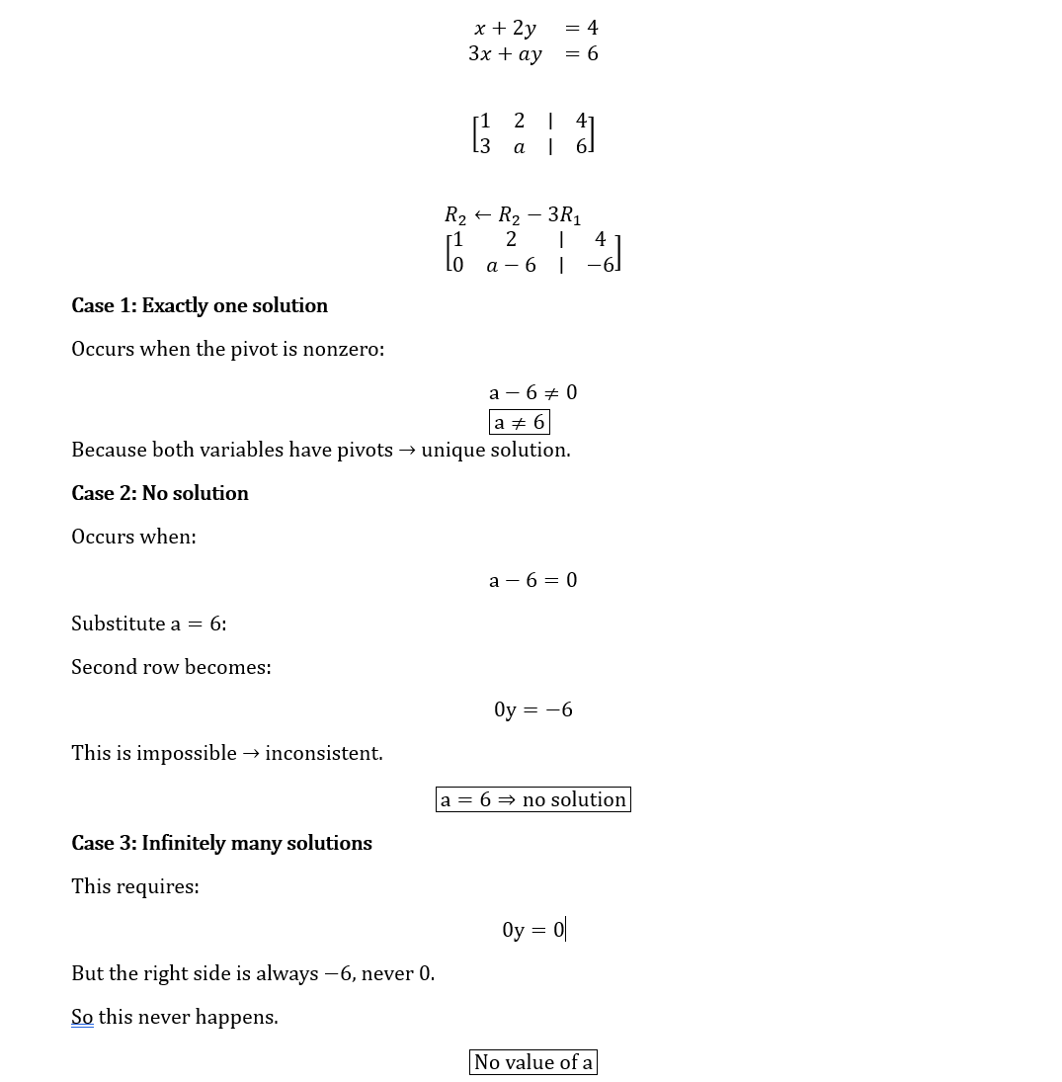
MARKING SCHEME

Q. 4 Since $A$ is invertible, there exists a matrix $A^{-1}$such that
$$AA^{-1}=A^{-1}A=I.$$
Take the transpose of both sides of the equation $AA^{-1}=I$:
$$\left(AA^{-1})^{T} = I^{T}.\right.$$
Using the properties of transpose,
$$\left(AA^{-1})^{T}=(A^{-1})^{T}A^{T}\text{and}I^{T}=I.\right.$$
Thus,
$$\left(A^{-1})^{T}A^{T} = I.\right.$$
Similarly, taking the transpose of $A^{-1}A=I$gives
$$A^{T}(A^{-1})^{T}=I.$$
Therefore, $\left(A^{-1})^{T}\right.$is both a left and right inverse of $A^{T}$.
By uniqueness of the inverse, we conclude that
$$\left(A^{T})^{-1}=(A^{-1})^{T}.\right.$$
MARKING SCHEME

